**TECHNOLOGY INNOVATION AGENCY’S**

**EXTERNAL EXPERTS’ REGISTRATION GUIDELINES**

1. **INTRODUCTION**
   1. The Technology Innovation Agency (TIA) is an entity of the Department of Science and Innovation (DSI). TIA is mandated through the Technology Innovation Agency Act, No. 26 of 2008, to promote the development and exploitation of discoveries, inventions, and innovations to improve the quality of life for all South Africans by bridging the innovation chasm between research and commercialisation.
   2. TIA’s objective is to support the state in stimulating and intensifying technological innovation to improve economic growth and the quality of life of all South Africans through the development and exploitation of technological innovations.
   3. TIA investment process approach is end-to-end process design from sourcing of opportunities, assessments, Due Diligence (DD), approval, disbursements, project monitoring and evaluation and exit or commercialisation. TIA’s investment process is depicted in the diagram below.

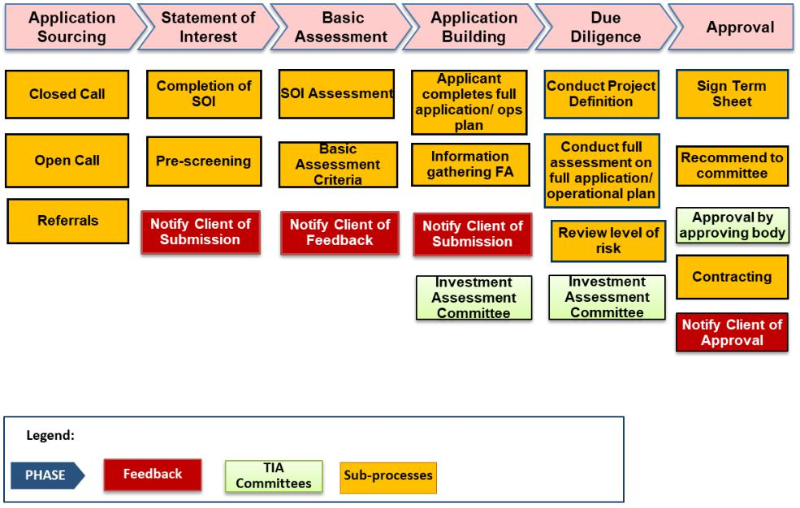

1. **PURPOSE**
   1. TIA has established an expert database and extends an invitation for individuals or service providers to register as prospective suppliers or experts on the expert database.
   2. The selected expert from the database will support the agency in assessing, evaluating, and verifying applications for investment including access to leading knowledge as and when required. This will include, DD investigations, Application assessment, Project audit reviews, Valuations, Deal structuring, Post investment, Business rescue, Thought leadership, Forensic audit investigations and Final project programme performance reviews.
   3. Through the expert database the Agency intends to broaden the list of independent subject matter experts to build and strengthen TIA’s capacity.
2. **SCOPE OF WORK**
   1. **Pre – Approval Stage**
      1. Utilisation of External Experts will be considered where expert opinions on specific and specialised technology areas, financial analysis, commercial viability, and market intelligence might be required and to assist in providing an independent input and evaluation in the TIA DD process.
      2. The generic scope of work normally conducted at the DD stage is outlined in Table 1 below. This includes conducting project definition workshops aimed at outlining the project scope, deliverables, risk, budget and timelines.

**Table 1:** TIA DD activities

| **Due Diligence** | **Due Diligence Description** |
| --- | --- |
| **Intellectual**  **Property** | * + Novelty Search   + Prior art search   + Intellectual Property strategy   + Contracts   + IP ownership   + Infringement (as and when required) |
| **Commercialisation** | * + Business and market readiness   + Market research and analysis (market segmentation,   customer analysis and size of the market)   * + Industry and competitor analysis   + Sustainability of the commercialisation strategy and Industry   dynamics and competitor behaviour   * + Relationship management   + Route to market   + Return on investment   + Socio-economic impact   + B-BBEE and transformation analysis |
| **Finance** | * + Tax structuring and advisory   + Financial modelling, financial health of applicant, applicant   credit checks, debt and other liabilities   * + Confirmation of tax compliance   + Evaluation and exit structuring |
| **Technology** | * + Technology analysis (TRL, progression, technology uptake)   + Technological merit   + Procurement, capex, regulatory issues |
| **Legal** | * + Corporate Governance   + Contractual DD (Collaborations, third-party subcontracts, license agreements)   + Legislation / regulatory compliance   + Prior existing relationship between parties   + Conflict of interest |
| **Team** | * + The team can deliver and execute, i.e. has the requisite skills / experience, and / or has demonstrated access to such   (Business / entrepreneurial and technology)   * + Subcontracting if the team does not have the necessary   capability   * + The team is drawing salary from the project cost. If so, each   team member's specific commitment to the project in respect  of time and deliverables is indicated. Is there a register company with CIPC, up to date tax clearance and current CSD registration?   * + Necessary business, technology and strategic partners are in place AND committed. |

* 1. **POST-APPROVAL STAGE**
     1. As part of TIA’s investment portfolio review, external experts may be required to conduct a review on the project and/or innovation programme performance. These would cover:
        1. Analysis of the original funding application and any other amendments made during the funding period:
     2. Feasibility of the technology
     3. Stage of technology development
     4. Competing technology development
     5. Commercial viability
     6. Potential time to market
     7. Intellectual property and new knowledge generated
     8. Risk assessments
        1. Analysis of milestones and deliverables
     9. What the project leader was supposed to accomplish.
     10. What has been achieved / impact assessment; and
     11. Clarity of milestones and deliverables
         1. Project Plan
     12. Adequacy of project plan going forward.
     13. Ability to meet timelines set out.
     14. Accuracy and comprehensives of budgets, forecasts, and business plans; and
     15. Risk assessments and mitigation plans.
         1. Commercialisation
     16. Technology transfer and market up take
     17. Technology diffusion
     18. Enterprise Development and Management
     19. New Venture Creation
         1. Workout and Restructuring
     20. Valuation and investment returns
     21. Exit options: (business rescue, liquidation, deregistration, divestment, recoveries, disposal of assets)
         1. The External Expert could also be used as nominee directors or observers on investee boards.
  2. **Scope of Work in Other Areas**
     1. As part of TIA’s internal audit process, external experts may be required to:
        1. Perform project related audits to determine whether the funds disbursed by TIA has been managed economically, efficiently and effectively, as per the agreement with TIA. The scope of work of the external experts will be determined on a case-to-case basis, based on the specific audit work / procedures required. In general, the primary objective of each project audit will be to provide an independent and objective level of assurance relating to (amongst others):
        + Reviewing the internal control environment and systems of internal control.
        + Examining, on a test basis, evidence supporting the amounts and disclosures in the financial reports.
        + Determining compliance with key terms of TIA funding agreements.
        + Evaluating the overall use of TIA’s funds; and
        + Reviewing and provide advice on matters of governance, compliance and risk management.
     2. Perform any internal audit or project audit investigations, ad-hoc and/or specialist audit services (e,g. forensic services) as and when requested by TIA.
     3. The expected output of each assignment will be a comprehensive report detailing the outcomes from each assignment, the opinion in each instance, as well as detailed recommendations and proposed measures of improvement for TIA relating to governance, processes, systems of control, financial management, etc. The activities related to this will include (amongst others):
        1. Completion of all working paper files i.e., planning, fieldwork, reports, etc.
        2. Communication of audit findings to the Head of Internal Audit (or directly to TIA’s management, Audit and Risk Committee and Board); and
        3. Provide the organisation with draft and final reports.

* 1. **EXPERTS RESPONSIBILITY FOR DD WILL BE:**

1. Conducting assessment and/ or DD investigation on specific funding application and/ or innovation programme related to their field of expertise.
2. Preparing and submitting assessment and / or DD investigation reports within the stipulated timeframes.
3. Participation in on-site project definition workshops set to unpack the project milestones, deliverables, activities, timeline, risk, and cost.
4. Providing written recommendations on each funding application.
5. Presenting their findings to TIA’s approval committees, as and when required by TIA.
6. **MINIMUM REQUIRED QUALIFICATION AND KEY FIELD OF COMPETENCIES**
   1. Individuals interested in serving as External Experts must have the following expertise listed in Table 2 below:

**Table 2: Desired expertise**

| **SECTOR KNOWLEDGE** | **LEGAL AND IP** | **COMMERCIALISATION** | **OTHER AREAS OF EXPERTISE** |
| --- | --- | --- | --- |
| Health | Novelty Search | Business and market readiness | Business rescue |
| Agriculture | Intellectual Property strategy | Market research and analysis (Market segmentation, customer  analysis, segmentation and size of the market) | Project audit reviews |
| Information Communication and Technology | Infringement | Industry and competitor analysis | Deal structuring |
| Advanced Manufacturing | Litigation | Sustainability of the  Commercialisation strategy and Industry dynamics and competitor behaviour | Post investment |
| Energy | IP ownership | Route to market | Thought leadership |
| Natural Resources | Commercial law | Return on investment | Forensic audit investigations |
| Industrial Biotech |  | Socio-economic impact | Quality assurance |
| Indigenous Knowledge Systems |  | B-BBEE and transformational  analysis | Final project programme performance reviews |
| Biotechnology |  | Valuations |  |

* 1. A minimum of five (5) – ten (10) years of experience in the relevant field of expertise as outlined in 4.1 above.
  2. A minimum of three (3) - 5 years of experience as an external expert in technology innovation.
  3. Experience in developing technology innovation related project plans (milestones, deliverables, activities, project risk and cost).
  4. Experience in evaluating project economic effectiveness and efficiency and applicability of B-BBEE.
  5. Capability in providing concise and thorough reports for the following:
     1. Technology innovation assessments;
     2. DD investigations and recommendations;
     3. Internal audit / project audit investigations;
     4. Ad hoc and / or specialist audit services e.g., forensic services; and
     5. Strategies.

1. **APPLICATION REQUIREMENTS**
   1. **Applying as an Individual**

Interested applicants applying as an individual must submit the following documentation with their application:

* + 1. Detailed curriculum vitae specifying expertise, based on skills and experience as outlined in section 4.1 above.
    2. Reference letters from a minimum of 3 – 5 organisations were technology innovation funding application assessments and / or DD investigations was conducted, or work completed in the experts area of expertise
    3. Other documents required if applicable:
       1. Written approval to do other work if expert is employed by a government institution.
       2. In the case of international experts, an SBD1 form needs to be completed, submitted to SARS for a directive.
  1. **Applying as a Company**

Interested applicants applying as a company must submit the following documentation with their application:

* + 1. Detailed curriculum vitae specifying expertise, based on skills and experience as outlined in section 4.1 above.
    2. Reference letters from a minimum of 3 – 5 organisations were technology innovation funding application assessments and / or DD investigation was conducted, or work conducted in the expert’s area of expertise.
    3. Company registration documents (CIPC / CSD / Lexus Nexus)
    4. Tax clearance certificate for local experts
    5. BBBEE certificate for local experts
    6. Other documents required if applicable:
       1. Written approval to do other work if expert is employed by a government institution.
       2. In the case of international experts, an SBD1 form needs to be completed, submitted to SARS for a directive.

1. **APPLICATION EVALUATION PROCESS**
   1. Applications received which does not include the mandatory documents outlined in Section 5 above will not proceed to the vetting stage and will not be considered.
   2. Applications received will be vetted through an open and transparent based on the criteria outlined in Section 5 above.
   3. Applications that have completed the vetting process and successfully meets the outlined criteria will be onboarded on TIA’s expert database.
   4. Moreover, TIA will on a random basis and based on the volume of funding applications received, choose from a database which external experts will be suitable for the assignment.
   5. Experts selected from the expert database for a suitable assignment will be required to sign a non – disclosure agreement / confidentiality agreement with TIA
   6. Taxation will apply in accordance with the South African income tax regulations (as applicable)
   7. The individuals credit status will be determined before being included in TIA external expert database.
2. **REMUNERATION**

Experts will be remunerated according to the DPSA guidelines on consultancy fees applicable.

1. **APPLICATION SUBMISSION**

Applications with supporting documentation must be submitted via the link below:

<https://www.tia.org.za/blog/2023/02/17/invitation-to-register-on-the-tia-database-of-external-experts/>

For further information, please email [experts@tia.org.za](mailto:experts@tia.org.za)