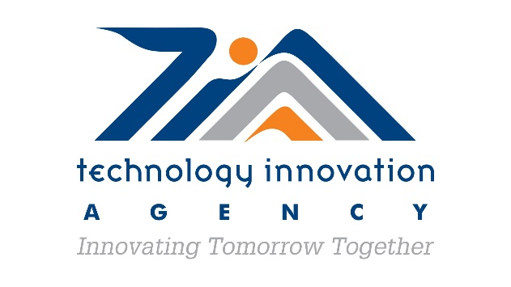
Press Release

SOUTH AFRICAN START UP AND TIA SIGN MOU AND TECHNOLOGY TRANSFER AGREEMENT WITH UNIVERSITI TEKNOLOGI MALAYSIA FOR BIOPROCESSING DEVELOPMENT

In a culmination of years of work and interactions, the Technology Innovation Agency (TIA), an entity of the Department of Science and Innovation (DSI), and the Universiti Teknologi Malaysia (UTM) have signed a Memorandum of Understanding (MoU) to collaborate in various areas of bioprocessing, including technologies for the production of mushrooms bioactives.

Currently, bioprocessing activities undertaken in South Africa, reside mostly in large enterprises in beverage and pharmaceuticals industries. There is, however, minimal bioprocessing activity in small and medium enterprises, the limited activity can be attributed to the cost of technology development and requirement of CAPEX investment associated with bioprocessing activities.

The MoU which was signed on Monday, 31 May 2021 by the TIA Acting Chief Executive Officer, Mr Patrick Krappie and the Vice Chancellor of UTM, Prof Datuk Ts. Dr. Ahmad Fauzi bin Ismail presents an opportunity for enhancing South African based competency on mushroom based fermentation. This would aid in the production of mushroom and mushrooms compounds for application in industries such as food, beverages, cosmetics and pharmaceuticals. The liquid cultivation offers an opportunity for production of consistent and high-quality inoculum that can be available on demand without reliance on natural conditions.
The MoU will support TIA on its mandate to drive the implementation of the Bio-economy Strategy of the DSI. Proficiency in the development and deployment of bioprocessing technologies is critical for the achievement of the objectives of the strategy.
The Bioprocessing Platform situated in Umbogintwini (KwaZulu Natal) is part of the support services that TIA provides to innovators in the bio-economy. The Platform provides scientific support and access to high-end technological infrastructure to various stakeholders, such as, small, micro and medium enterprises (SMME’s), higher education institutions (HEI’s), Science councils and research institutes for the translation of new knowledge and inventions into innovations. The Platform offers a unique combination of technological capabilities encompassing diagnostics, analytical services and bioprocessing within a single facility, in order to meet the requirements of various users.
As part of the MoU, TIA and UTM will be able to collaborate in the areas of Human Capital Development through an exchange programme for post graduate students in the field of bioprocessing; continued learning with the Bioprocessing Platform and local universities hosting the UTM course on bioprocess engineering. In addition to the short courses offered by UTM in cosmeceuticals and fragrances; food and nutraceuticals and herbal and phytochemical processing, such know-how would also be made available in South Africa through the Bioprocessing Platform.
“This is a proud moment for TIA and a key milestone in the relationship between TIA and UTM. The relationship has been in the making for a number of years and has enjoyed the support of the DSI. In supporting a vibrant National system of Innovation, we are pleased that the MoU includes student exchange and the opportunity for SMME’s to gain key skills from UTM. This collaboration is also an opportunity to demonstrate a practical example of South-South collaboration,” says Patrick Krappie, Acting Chief Executive Officer, TIA.

As part of the MoU between TIA and UTM, a Gauteng based start-up Sawubona Mycelium (Pty) Ltd also signed a technology transfer agreement with UTM. Through this technology transfer, Sawubona Mycelium (Pty) Ltd aims to construct a low-tech specialised mushroom production facility that would replicate similar yield as a high-end liquid production facility. This technical know-how will introduce a new paradigm to fermentation technology which could subsequently be deployed in many other production campaigns of high value biomolecules.

“Reaching this milestone for us as a start-up is very important in progressing our plans for biomolecule production and with the support from TIA and the technology transfer agreement will give us access to a process and technology that we require to be able to develop products. Barriers to entry are one of the major challenges for start-up companies like ours. We are looking forward to implementing a technology that will help us reduce the capital costs associated with setting up fermentation systems,” says Neo Moloi, Chief Operating Officer, Sawubona Mycelium.

The commercialisation of bio-based technologies, including indigenous knowledge systems (IKS), is not highly developed in South Africa. The Asian experience, particularly that of Malaysia, in this regard is well developed. The interventions that have been developed through UTM in support Malaysian SMME’s to develop and commercialise IKS products is an ideal blueprint for South Africa to emulate. Harnessing the knowledge and experience of the Asian market in developing IKS based products and processes through this strategic partnership would assist in enhancing South African capacity to equally commercialise IKS products.

Ends.
Issued by: Technology Innovation Agency
Enquiries: Vusi Langa: Head Marketing and Communications
012 472 2839
073 766 0200
vusi.langa@tia.org.za

About TIA
The Technology Innovation Agency (TIA) is a public entity in South Africa that serves as the key institutional intervention to bridge the innovation chasm (gap) between research and development from higher education institutions, science councils, public entities, and private sector, and commercialisation (beneficiation). TIA was established in 2010 and has a national reach with offices in KwaZulu Natal, Western Cape and Gauteng. The main thrust of the mandate of TIA is funding and supporting innovative technologies that show potential to be commercialised. The organisation also has programmes that provide non-financial support to innovators and SMMEs. Lastly, TIA is a catalyst and enabler of innovation through various partnership initiatives locally, in the African continent and globally.
For more information, visit www.tia.org.za
Follow us on social media:
Twitter: @tiaorgza
Facebook: Technology Innovation Agency
LinkedIn: Technology Innovation Agency
Youtube: Technology Innovation Agency

